**Cloud computing practical 2**

1) In search tab search S3 and select it.

2) Now select create bucket

3) You can create bucket name anything you want. Here I have done it as nikibucket21

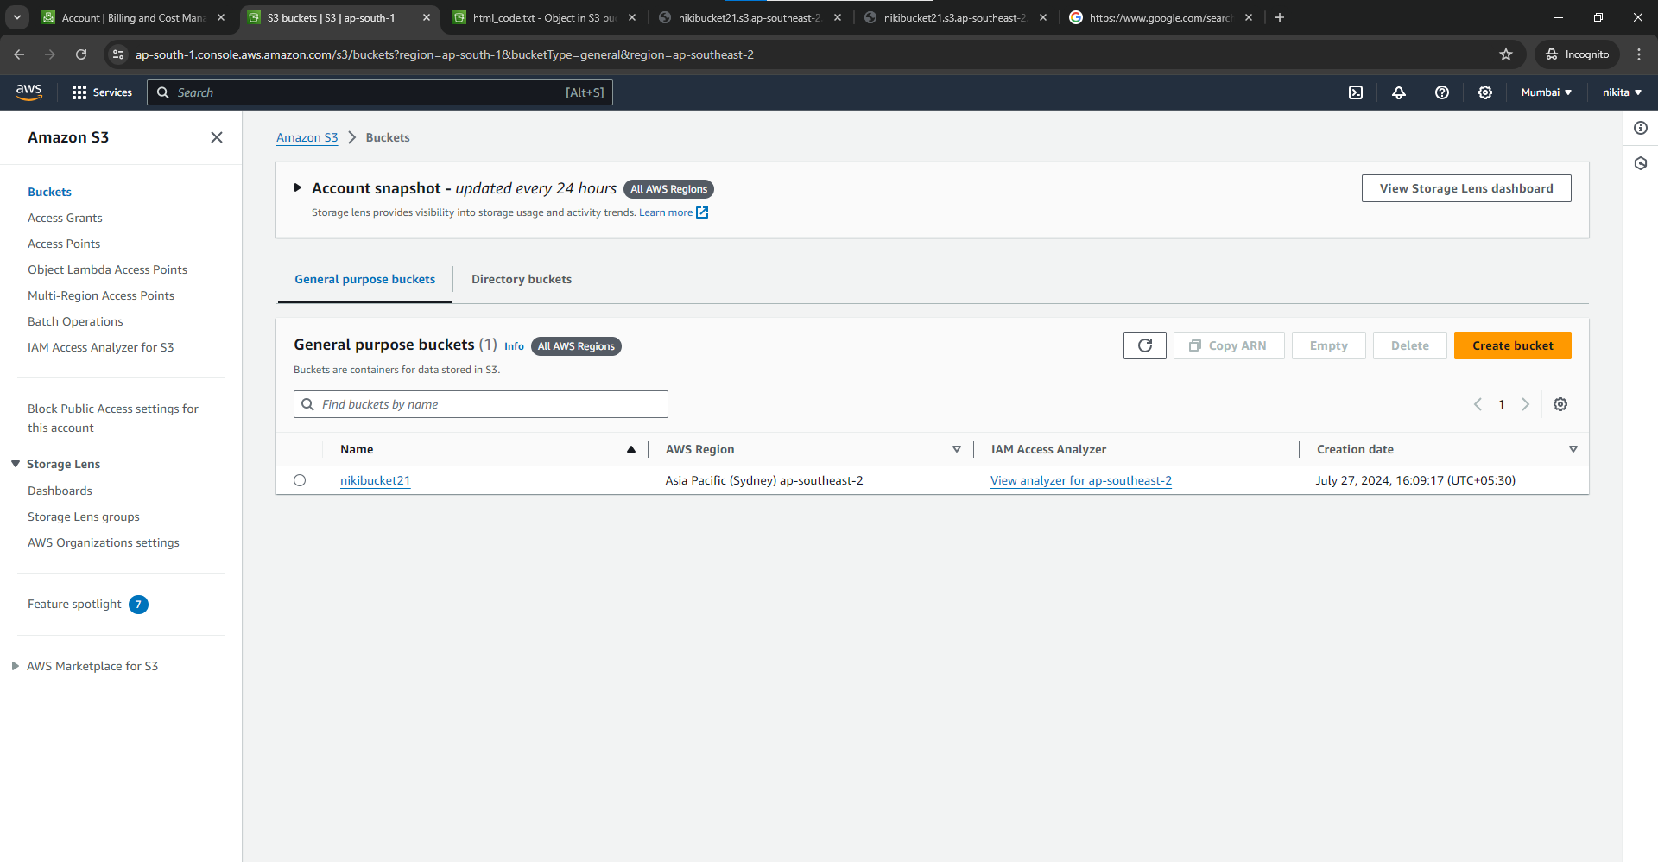

4) Select create folder as per your name choice. I have named it as image.

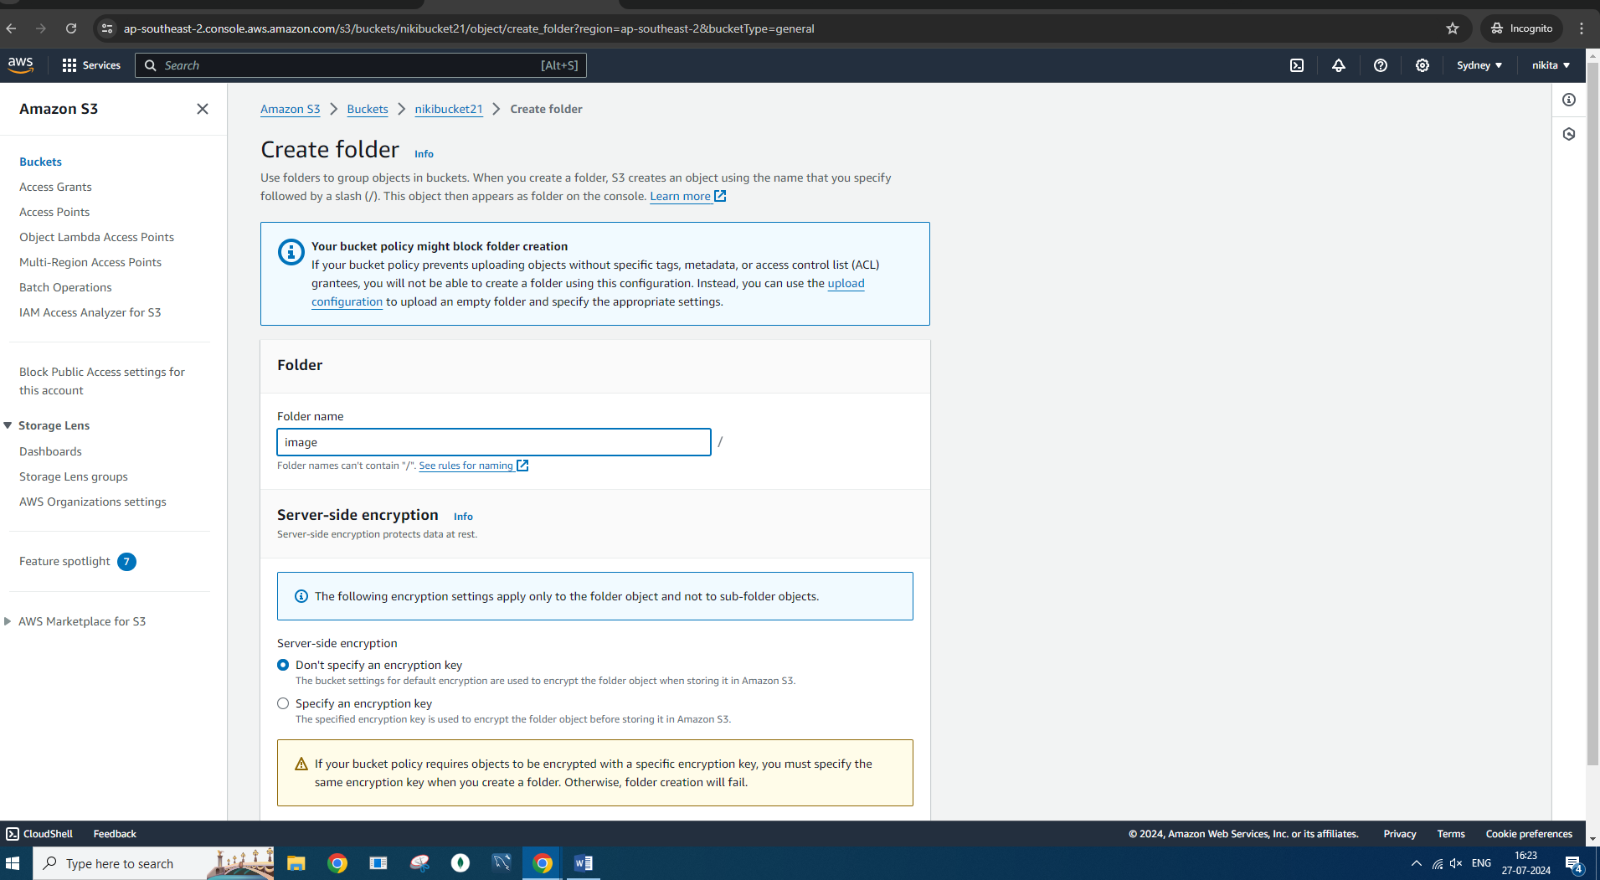

5) Upload one image of your choice by selecting add files in your folder and upload iT 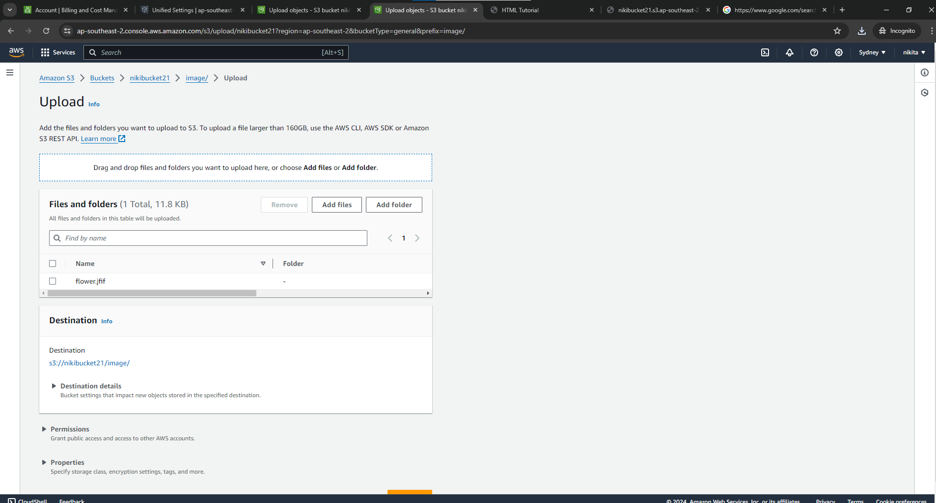

6) After upload check status

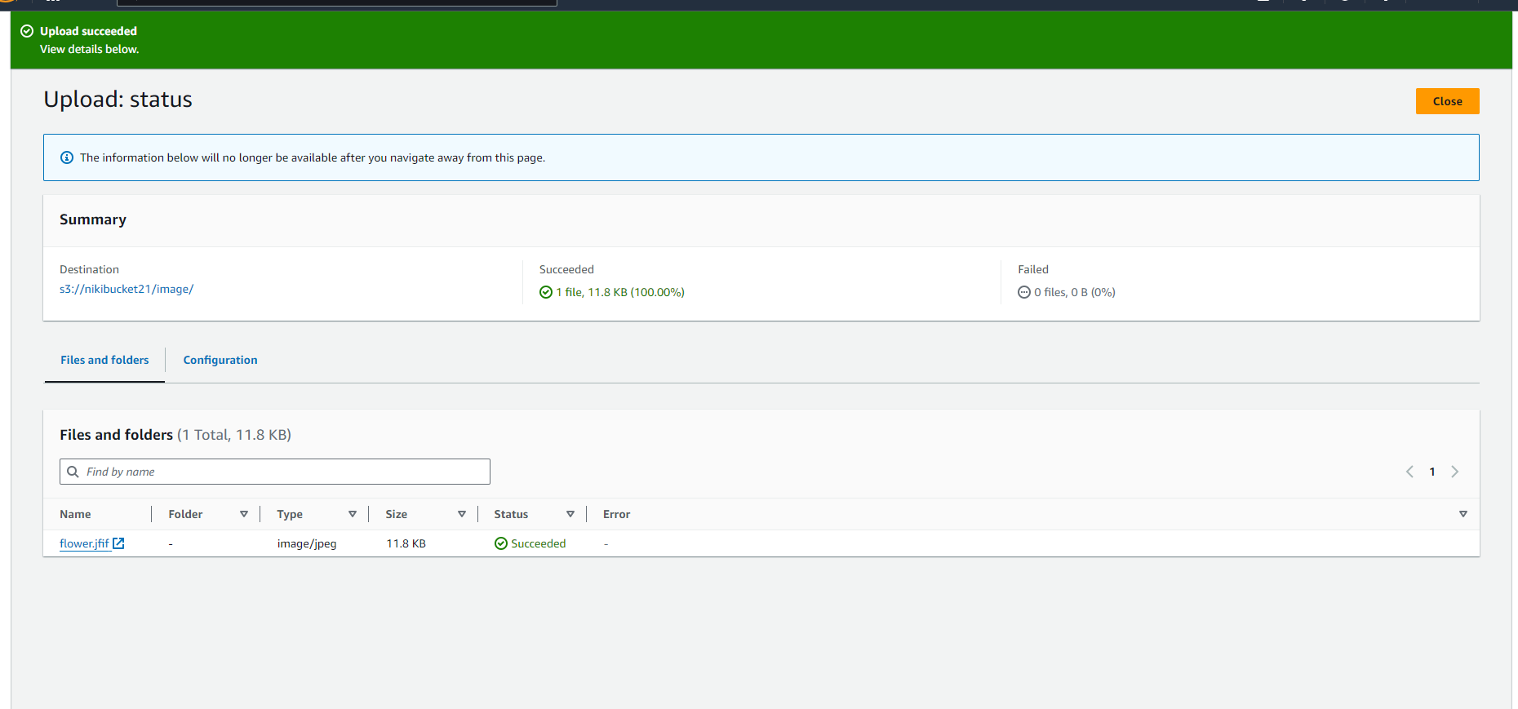

7) Open your image



1) CREATE A BUCKET

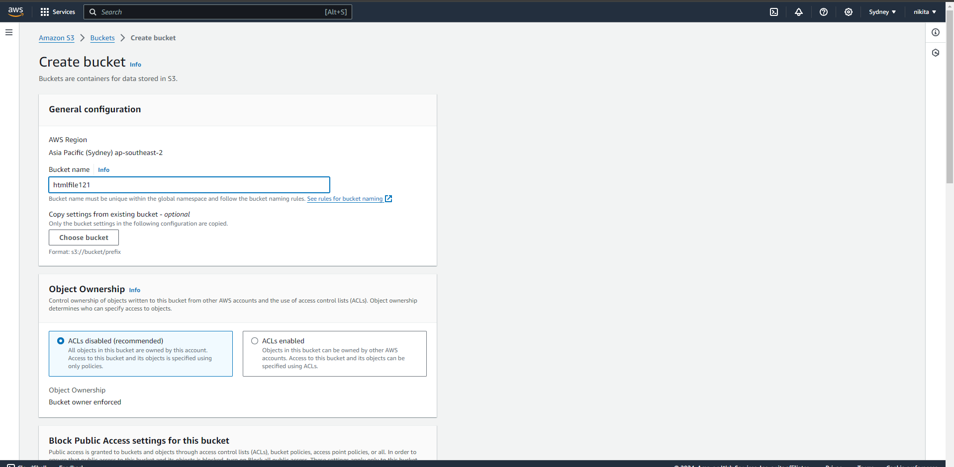

2)

